**Component Diagram**

A component diagram describes the organization of the physical components in a system.

**Basic Component Diagram Symbols and Notations**

**Component**

A component is a physical building block of the system. It is represented as a rectangle with tabs.  
[Learn how to resize grouped objects like components.](http://www.smartdraw.com/resources/tutorials/Objects)

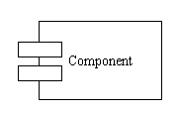

**Interface**

An interface describes a group of operations used or created by components.

Interface

**Dependencies**

Draw dependencies among components using dashed arrows.  
[Learn about line styles in SmartDraw.](http://www.smartdraw.com/resources/tutorials/Lines)

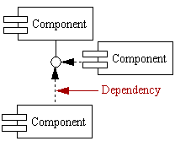

**COMPONENT DIAGRAM:**

